**NAME: JEEVITHA.S-192324020**

**DATA BASE MANAGEMENT SYSTEM FOR DATA APPLICATIONS(CSA0555)**

**ASSIGNMENT 14 : STUDENTS DETAIL(GRADE)**

Write a PLSQL program using control statement to generate a progress report for the student.

(a)with table

CREATE TABLE

create table s(name varchar(20),id number,m1 number,m2 number,m3 number);

INSERT VALUES

insert into s values('jeevi',100,20,15,64);

insert into s values('jai',101,50,15,60);

insert into s values('joe',102,90,95,60);

insert into s values('anitha',103,70,55,30);

insert into s values('surya',104,50,35,30);

CODE

declare

grade number(20);

begin

select s.m1 into grade from s where id=103;

if grade>90 then dbms_output.put_line('out standing');

elsif grade>80 then dbms_output.put_line('distinction');

elsif grade>70 then dbms_output.put_line('good grade');

elsif grade>60 then dbms_output.put_line('first class');

elsif grade>50 then dbms_output.put_line('second class');

else dbms_output.put_line('fail');

end if;

end;

/

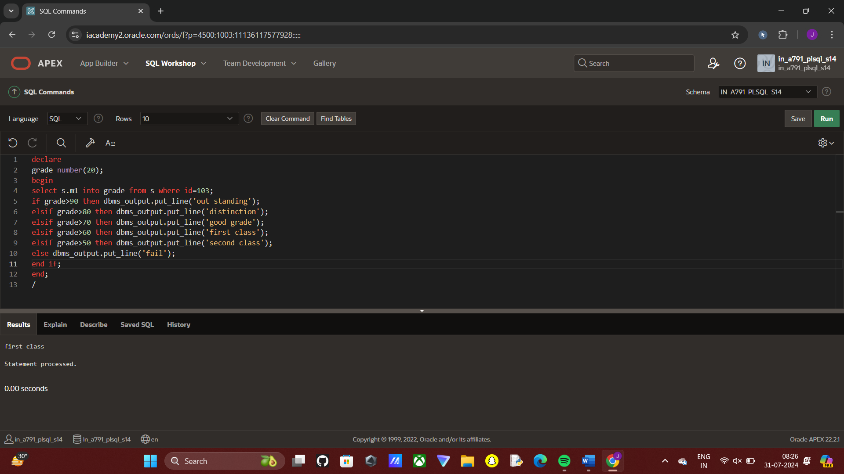

(b) without table

CODE  
declare

m1 number:=10;

m2 number:=25;

m3 number:=22;

av number(10,2);

begin

av:=(m1+m2+m3)/3;

if av>90 then dbms_output.put_line('Out standing');

elsif av>80 then dbms_output.put_line('Distinction');

elsif av>70 then dbms_output.put_line('Good Grade');

elsif av>60 then dbms_output.put_line('First class');

elsif av>50 then dbms_output.put_line('Second class');

else dbms_output.put_line('Fail');

end if;

end;

/

